Discussion Portal
Software Requirements Specification
Version <0.3>
By: SOURABH KAUSHAL

Software Requirements Specification

Introduction
Our software is a discussion portal for students and faculty and will be participated by different
Sections of this university such as financial department, registrar office etc. and will be a portal for different issues in this university.

Purpose

Our software is an online portal where the purpose is to reduce the tedious effort that goes in reviewing the e-mails about the happenings in our university and sending it to every student, for example: lost and found of items, event notifications, no-dues clearance etc.

Users include students and faculty where anyone can put up a post about the above mentioned issues and anybody who logins into the portal can see the respective notification and can respond accordingly.

Scope

Primarily, this software is aimed for our own NIIT University keeping in mind the above mentioned issues. This software will include almost every department of this university and it will be feasible for both students and the faculty.

Later on we can sell this software for other universities as well because the mentioned problems is common in other universities as well to some extent.
The aim of this software is to make things organized and get it online so much of the tedious manual work can be reduced to simple online effort.

Overview

The remaining sections of this document provide a general description, including characteristics of the users of this project, the product's hardware, and the functional and data requirements of the product. General description of the project is discussed in section 2 of this document. Section 3 gives the functional requirements, data requirements and constraints and assumptions made while designing the software. It also gives the user viewpoint of product. Section 3 also gives the specific requirements of the product. Section 3 also discusses the external interface requirements and gives detailed description of functional requirements. Section 4 is for supporting information.

Overall Description

Product Perspective:
Our software being developed is a client-server interaction platform which will have a website for users to post their respective issues and a database will have those posts and users information.
This software is being made with an intention of simplifying manual things by making them online.

2.2 Operating Environment:

Our software will work on Apache server with MySql for database management and Visual studio for backend coding.

Product Features:

2.2.1

Our online portal will allow users to interact with other users when they lose something in the university, they can write a post in the “Others” section.

If someone finds something in this university then they can take a photo of that
thing and can post it in the “Others” section with his/her contact details.
Once the thing reaches the owner the post gets deleted by the admin or automatically.

For cultural events, if someone needs a venue for practices then they can ask the
permission in the cultural section with a post and the respective authority will revert back and the post will be made public for others to see.

If a speaker comes to the university for a talk then a post will be created in the
academic section and the students can directly see the post there with all the details related to speaker and can respond with a Yes or No if they want to attend the talk.

User Classes:

Customers: The customers of this software are currently the students and faculty of NIIT University who require to communicate for issues mentioned in the above section.

Operating Environment:
Our software will work on Apache server with Mysql for database management.

Design Constraints:
We are making this software on .net framework where our Front end work which is our Designing part will be based on HTML, CSS, Java script, and our Back end work which is coding part will be done on C#. For making the software we will be using Microsoft Visual Studio 2008 for our Front End and Back End work and Microsoft SQL Server Management Studio 2012 for the database work.

External Interface Requirements:

3.1 User Interface Functionality:

- The user will login on the login webpage where the user will use the provided credentials to login into the main website. Unauthorized users will get an error and they can’t login into the website.

- After the user logins in the main website, he can go to the home page of our website where the posts made by students and faculties will be present and then if he desires, he can act accordingly.
- There will be a drop down list which will contain three areas to generate posts namely:
- Cultural: To make posts related to cultural events, such as DJ Night, Audacity, Musical nights etc.
- Academic: To make posts related to academia, such as workshops, Quiz event etc.
- Invited Talk: To see and make posts regarding invitation of guest lecturers and organizing talks on various topics.

- There will be a section of Lost and Found, where a user can make a post about loss of a personal item and also post a picture of it if they have it.
- If a person finds an item then he can post the picture and its details along with his contact details and the post will be public so everyone can see the post and can respond accordingly.
- For admin, he will have a separate login credentials and he will responsible for reviewing the post and adding and removal of users.

  - Software Interface Functionality:
- Our software database will be supported by MySql server and will be integrated with our website which will include the user id’s, passwords and posts of users.

- There will be a review system in our software in order to avoid the misuse of our software. Every post will be sent to an admin who will review the post and will post accordingly.

- There will be a report button to avoid the misuse of our website.
Whenever someone finds a post abusive or is just made for the sake of fun, then other users can report it and the accused id will be sent to admin and further actions will be taken accordingly.

  - Hardware Interface Functionality:
Our software needs a fully functional computer having internet connectivity.

System Features:

Use Case :

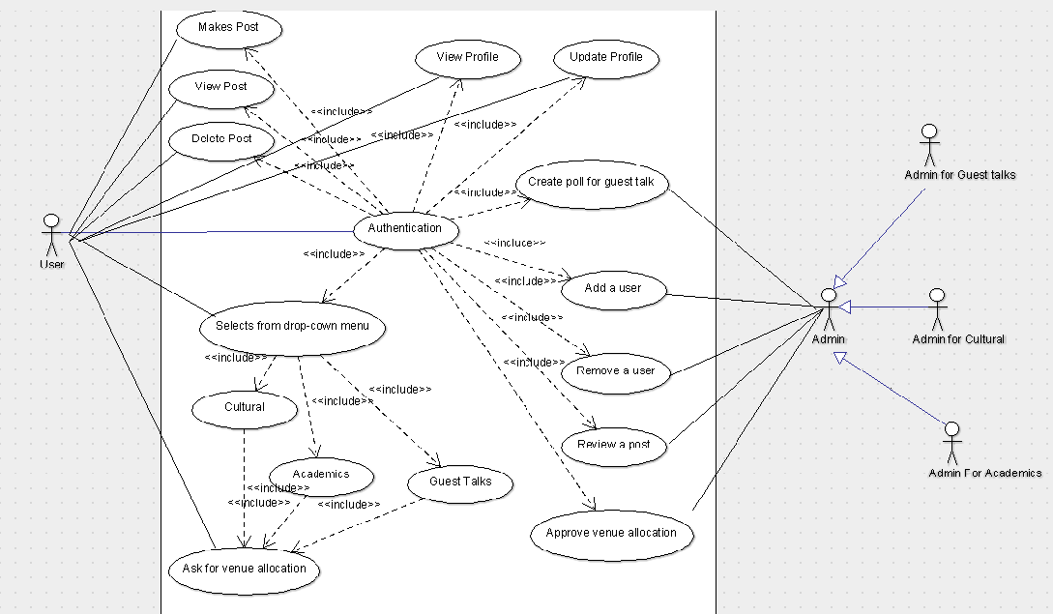

Requirement Table:

RID |  | Requirement Name |  | Applicable Roles |  | Description
1. |  | Login and Logout |  | User and Admin |  | User can login from the login page and can make or view post.  Admin can login from the same login page and can add or remove users.
2. |  | Selection from Drop down  List. |  | User |  | User will have 3 choices in the drop down list namely:  Cultural, academic and Guest lecture. He can view or make post in these 3 sections.
3. |  | Lost and Found Enquiry |  | User and Admin |  | User can make a post or post a picture if he loses something and other user can post the picture with details if he finds something.
4. |  | View Post |  | User |  | User can view posts in different sections
5. |  | Make Post |  | User |  | User can make posts in different sections.
6. |  | Report Post |  | User |  | User can report a post if it contains abusive content.
7. |  | Delete Post |  | Admin and User |  | Admin will be having the authority to delete a post if he finds the content useless.
8. |  | Update Profile |  | User |  | User can view and update his profile information such as password or email id.
9. |  | Location Allocation |  | User and Admin |  | User can ask permission for a particular location in different sections.  Admin after the approval from his superiors can grant the permission accordingly.
10. |  | Add User |  | Admin |  | Admin will have the authority to add a user.
11. | Remove a user |  | Admin |  | If a user is no longer a part of this college then the admin can remove the user from the database.
12. | Create Poll for guest talk |  | Admin and User |  | Admin or User can create a post having a poll for a guest lecture which will give a proper count of students and the number will be sent to respective authorities.

4.1 View and Make a post:

- The portal shall enable user to select from dropdown menu for the section he wants to make a post in.

- The portal will enable the user to view all the posts on the home page.

- The portal will allow the admin to review the post and take necessary actions.

Maintain customer profile:

- The software will allow user to create profile and he will login with credentials provided by the university.

- The software shall authenticate user credentials to view the profile.

3. The software shall allow user to update the profile information.

  - Make post in the lost and found section:

- User can post a picture and details of something he/she has lost.

- Any user who finds the item can post the picture and submit it and can post the details and click on the found button to delete it from the database.

  - Event notification and location allocation:

User can select cultural section from the drop down menu and can post about an upcoming event and it’ll be seen by the respective admin and he will have a superior admin and after both of them approve the request that post will be made public.

  - Academic Notifications:

If a user wants to conduct a guest lecture or a workshop in the campus then he/she can go to the Academic section from the drop down menu and can post for the same.
If they need a location then he has to request it from the admin and after proper approval by the authorities he can have the location for the event.

  - Guest Lecture Notifications:

Whenever there is a guest lecture in the campus, a full profile of the speaker along with his achievements and youtube references will be provided in this section and a poll will be created to have a number of people interested in the lecture and it will have a feedback windows where after attending the talk, user can give his/her honest feedback which will be sent to the higher authorities for assessment.

- Other Non-Functional Requirements:

Reliability & Availability:

Back-end Internal Computers

The system shall provide storage of all databases on redundant computers with automatic switchover.

The system shall provide for replication of databases to off-site storage locations.

Internet Service Provider

The system shall provide a contractual agreement with an internet service provider for access with 100% availability.

Performance:

The product shall be based on web and has to be run from a web server.

The product shall take initial load time depending on internet connection strength which also depends on the media from which the product is run.

The performance shall depend upon hardware components of the client/customer.

Security:

Data Transfer

The system shall automatically log out all customers after a period of inactivity.

The system shall not leave any cookies on the customer’s computer containing the user’s password.

The system shall not leave any cookies on the customer’s computer containing any of the user’s confidential information.

Data Storage

The customer’s web browser shall never display a customer’s password. It shall always be echoed with special characters representing typed characters.

The system’s back-end servers shall never display a customer’s password. The customer’s password may be reset but never shown.

The system’s back-end servers shall only be accessible to authenticated administrators.

The system’s back-end databases shall be encrypted.

Supportability:

Configuration Management Tool

The source code developed for this system shall be maintained in configuration management tool.

Design Constraints

Web Based Product

There are no memory requirements
The computers must be equipped with web browsers such as Internet explorer.
The product must be stored in such a way that allows the client easy access to it.
Response time for loading the web page should take no longer than five minutes.
A general knowledge of basic computer skills is required to use the product.

